Lesson 11 Full Study Guide with Flowcharts

useEffect Lifecycle Flowchart
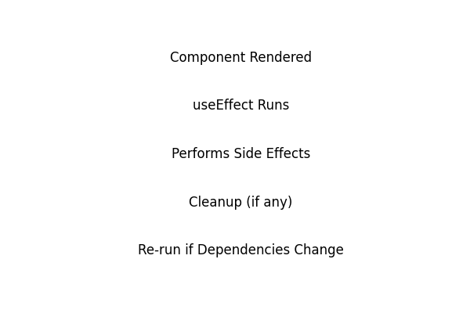

Dependency Array Behavior Flowchart
